Shop Small for the Holidays in Alexandria, VA
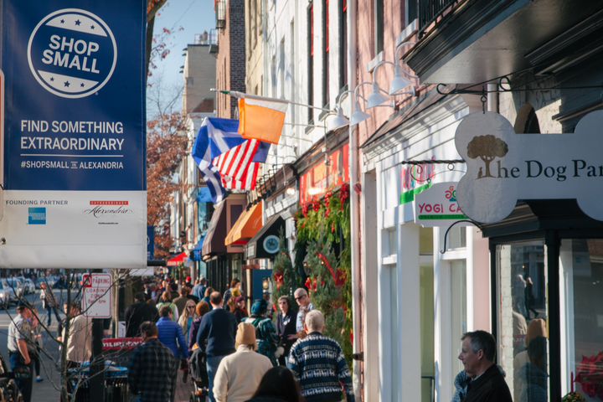
Image Credit: M. Chenet for Visit Alexandria
This holiday season, make your shopping experience memorable and worry-free in Alexandria, the DC region’s Shop Small headquarters for independent boutiques. You can opt small and shop a local experience in a magical setting of holiday wonder all season long.

New this year is 116 King Holiday Pop-Up and expanded Random Acts of Holiday Cheer. The season includes an alternative Black Friday experience on November 25, 2016 with free parking and deals from nearly 50 boutiques, and Small Business Saturday on November 26, 2016 with in-store activities in which visitors can meet the makers and small business shakers and enjoy exclusive “Shop-Taste-Create” experiences.
During the holidays, historic Old Town Alexandria is transformed into a winter wonderland reminiscent of a simpler time. Meet the makers and small business shakers at dozens of independent boutiques that welcome you with greenery at their doorsteps, offering everything from chic fashions and home décor to classic toys and gifts for dogs. With 80% of Alexandria boutiques and restaurants being independently owned, it is easy to get expert advice and products curated by local owners who are often on site to find the perfect gifts for everyone on your “nice” list.
Check out the Visit Alexandria blog at ExtraAlex.com for a full run down on the following:

116 King Holiday Pop-Up
November 10-December 31, 2016

Random Acts of Holiday Cheer
Saturdays November 26-December 24, 2016 from 11 a.m.-3 p.m.

Black Friday Alexandria
November 25, 2016

Small Business Saturday
November 26, 2016
Learn more about holiday shopping and events at VisitAlexandriaVA.com/holidays.

